**Q1.**

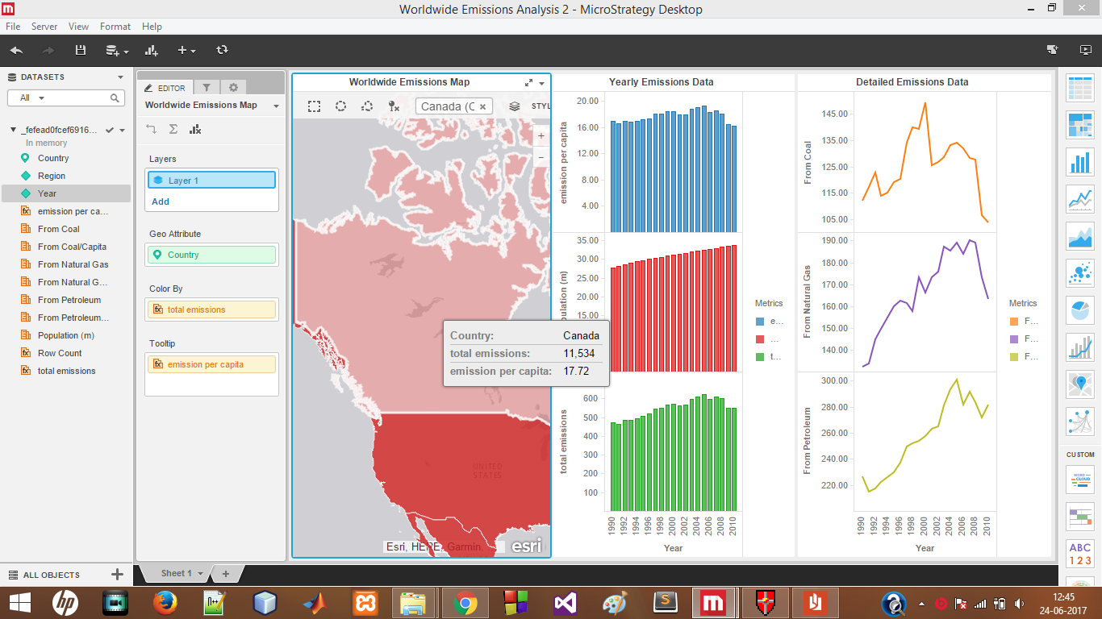

Q2. Overall emission is increasing continuously except for 2009

Q3. Because emission per capita in 2009 is reduced.

**USA and CANADA**

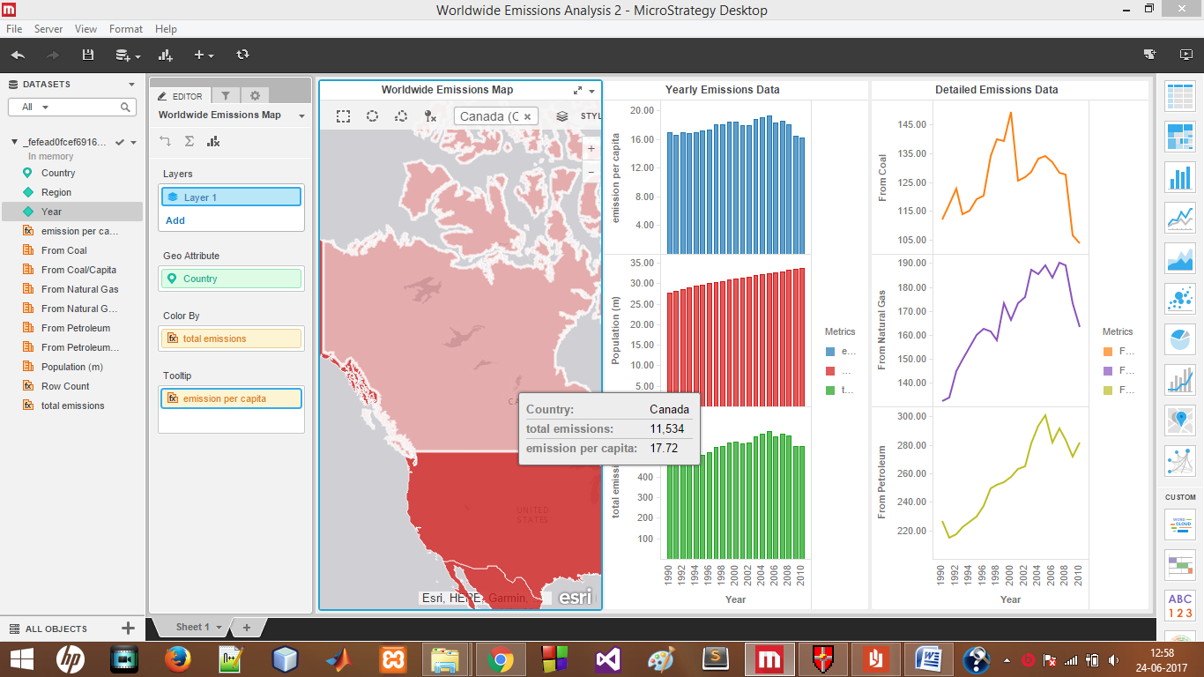

**pto**

